1 hour of time  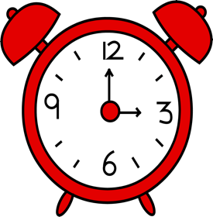 | 1 hour of time
1 hour of time | 1 hour of time
1 hour of time | 1 hour of time
1 hour of time | 1 hour of time
1 hour of time | 1 hour of time

